Engaging on the National Strategy and Action Plan for Family Violence and Sexual Violence: summary of engagement processes

Summary
New Zealand has unacceptable rates of family violence and sexual violence which
severely undermines the wellbeing of victims and their children, families and whānau. Communities and international bodies have signalled that Aotearoa New Zealand needs a National Strategy to build a shared understanding of family violence and sexual violence and how to prevent it.

The Minister for the Prevention of Family and Sexual Violence, Hon Marama Davidson, prioritised the development of a National Strategy and Action Plan to drive the system transformation needed to prevent and address family violence and sexual violence. In March 2021, Cabinet agreed to nation-wide engagement on the key elements of a National Strategy. Engagement was launched on 6 May 2021 in South Auckland at Ngā Whare Waatea Marae and ran until the end of June.
Engagement on the draft National Strategy and Action Plan sought to identify and build common agreement on the vision, goals and actions needed to reduce and eliminate family violence and sexual violence in Aotearoa New Zealand.
Reducing and eliminating family violence and sexual violence will require new ways of working across government and with tangata whenua and communities to empower a more people-and whānau-centred response. The engagement approach sought to model these news ways of working with communities by: supporting the capacity of communities to lead; creating enduring, trusting relationships between government and communities; and devolving leadership and resources.
Engagement was coordinated by the Joint Venture Business Unit (JVBU) as the office supporting the Joint Venture of the Social Wellbeing Board to Eliminate Family Violence and Sexual Violence (the Joint Venture). The JVBU supported communities to engage on their terms in places and ways that worked best for them, and with respect and consideration for the needs of diverse communities.
In addition to offering in-person and online community-led hui, the JVBU invited public submissions via Citizens Space and https://violencefree.govt.nz/, and promoted engagement opportunities widely across family violence and sexual violence networks. Submission material was made accessible including in alternate formats for disabled people.
From this engagement, the JVBU received a wealth of information and advice from communities and the sector that helped the Joint Venture to shape the National Strategy and Action Plan. This resulted in:
  - 120 tangata whenua-, sector- and community-led hui involving more than 2000 people
  - 1000 online, email, written and survey-based submissions; and
  - Over 260 women impacted by violence who participated in an independent survey run by The Backbone Collective.
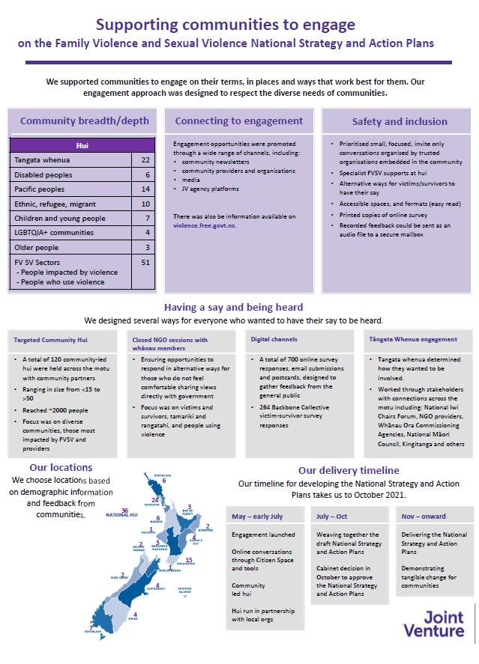

Engagement approach
The JVBU went through a ‘pre-engagement’ phase to inform the final approach to engagement. During the pre-engagement phase, the JVBU held a series of conversations in early 2021 to build an understanding of each of the target communities. These conversations included a range of stakeholders in the family violence and sexual violence sector and stakeholders in diverse communities.
Investing in these pre-engagement conversations enabled us to build on existing relationships and build new relationships that could enable genuine conversations during the engagement.
From over 40 pre-engagement discussions with different stakeholders and communities we heard that:
- Te Tiriti o Waitangi needs to be at the centre of the engagement process. Tangata whenua who are active in the family violence and sexual violence (FVSV) system must be enabled to come together to inform an engagement approach for iwi, hapū and whānau and hapori (communities).
- Guidance from stakeholders is needed to understand how to enable the participation of people impacted by violence, including that processes must be safe and inclusive, and centred around people impacted by violence.
- The diverse communities we talked to asked to lead their engagements to create safe and inclusive spaces for sharing their experiences and aspirations. Some communities said it might not always be appropriate for government representatives to be in the room.
- People impacted by violence should be involved in all stages of planning the engagement processes, there should be multiple options for providing feedback, with specialist workers available before, during and after engagement in case of personal disclosures or people needing support.
- People needed a range of simple tools and ways to engage digitally and in person.
This feedback and advice was incorporated into the design of an engagement approach that aimed to balance the diverse needs and aspirations of communities, and also ensured the approach supported the government’s needs.
The engagement approach was discussed with Dr Kim McGregor, Chief Victims Advisor to government, who was supportive that the approach would safely give voice to people impacted by violence. Dr McGregor particularly noted the importance of including a survey run by the Backbone Collective – a national coalition of survivors of violence against women in Aotearoa New Zealand. This survey provided a direct route for people impacted by violence to provide their feedback via an organisation that is trusted and known to them.
Engagement was coordinated by the JVBU and ran for 8 weeks from 6th May to the end of June 2021. Due to a delay in translating the engagement material into alternate formats for disabled people the engagement deadline was extended to 12 July 2021 for the disabled community.
As communities had said that effective engagement must be community-led, the JVBU supported communities to engage on their terms, in places and ways that worked best for them. Some communities identified and organised their own hui.
Due to the sensitive nature of the engagement topics and the safety risks around this engagement (e.g. disclosures of personal experiences, or aggravating behaviours), trusted organisations embedded in the communities helped to manage invitations for targeted and/or closed hui.
The National Strategy engagement packs provided a range of resources that communities could choose from. These resources enabled hui to be flexible by focusing on one, some or all aspects of the National Strategy depending on their community’s concerns and aspirations. Hui support and resources included note-taking support and support workers and community chosen Pou and any funding required for these resources.
Some hui were large and intersectional, others were small and specific. Some hui were led solely by communities, others jointly with the Joint Venture. Overall, the majority of hui with the family violence and sexual violence sectors were facilitated by the Joint Venture, whereas hui with communities were more often community-led.

Public submissions were invited via Citizens Space and https://violencefree.govt.nz/, and were promoted widely across family violence and sexual violence networks. Submission material was made accessible including in alternate formats for disabled people.

Engagement with tangata whenua
A series of wānanga with tangata whenua were held to seek advice and guidance on how to enable their effective participation in the engagement on a national strategy. Tangata whenua told us “they will invite us; they will share what they want and direct the process”.
The JVBU contacted those tangata whenua stakeholders and other networks whom we have existing relationships with. This included iwi Māori, whānau, people impacted by violence, people who have used violence, kaupapa Māori family violence and sexual violence providers and Whānau Ora commissioning agencies. In sharing information with tangata whenua stakeholders and their networks, tangata whenua invited the JVBU to work with them. The JVBU heard from regions that have their own family and/or sexual violence strategies and effective responses dealing with whānau, hapū and iwi.
To support engagement and the development of the National Strategy, the Joint Venture worked closely with a Tāngata Whenua Rōpū of Māori family violence and sexual violence leaders from across Aotearoa New Zealand. The Rōpū supported the analysis of insights from the tangata whenua engagement hui. The Rōpū provided recommendations and feedback to the Joint Venture and Ministers on framing for the National Strategy and the enduring relationship with tangata whenua required to address family violence and sexual violence.
To support engagement and development of the National Strategy, the Joint Venture worked closely with a Tāngata Whenua Rōpū of Māori family violence and sexual violence leaders from across Aotearoa New Zealand. The Rōpū supported the analysis of insights from the tangata whenua engagement hui. The Rōpū provided recommendations and feedback to the Joint Venture and Ministers on framing for the National Strategy and the enduring relationship with tangata whenua required to address family violence and sexual violence.
The intent is that a Ministerial Advisory Group will work alongside the Minister for the Prevention of Family and Sexual Violence providing independent advice and feedback on the implementation of Te Aorerekura: the National Strategy to Eliminate Family Violence and Sexual Violence.

Interpreting what we heard and finalising the National Strategy
All hui notes and submissions were handled by the JVBU ensuring strict data protection and confidentiality protocols. Hui notes and submissions were analysed, with any identifying information removed, and grouped into common themes. These themes helped inform a series of “What we’ve understood” documents, which were published on https://violencefree.govt.nz/ and provide a summary of the key issues that came through in the engagement.
The Joint Venture also worked with a team of Independent Advisors to support and review the understanding of hui and submission insights and the framing of the National Strategy language and outcomes. The 14 Independent Advisors are expert practitioners drawn from, or able to represent, the specialist sectors and focus communities (tangata whenua, people impacted by violence, disabled people, Pacific peoples, LGBTQIA+ communities, older people, children and young people, people who use violence and ethnic communities).

Limitations of the engagement approach
The engagement resulted in a higher than anticipated number of hui and submissions and a wealth of information that helped to shape the final version of Te Aorerekura: the National Strategy to Eliminate Family Violence and Sexual Violence. However, there were some constraints that also need to be acknowledged.
The engagement approach targeted those most impacted by family violence and sexual violence, some diverse communities, and family violence and sexual violence providers. Given the limited timeframes, it was not possible to reach everyone and some voices are lacking or missing.
The JVBU mainly worked through national bodies and networks to reach several of the communities. This included the national bodies for both the family violence and sexual violence sectors and the Rainbow Violence Prevention Network. Engaging providers who worked with individuals, communities and whānau was sometimes a more safe approach than engaging directly with people impacted by violence, particularly children and young people. However, it is possible that organisations and individuals not affiliated to those bodies or networks may not have been aware that the engagement was happening.
Targeting and grouping communities in this way resulted in some missed opportunities to highlight the voices of people whose identities intersect across multiple diverse communities, such as people who identify with the rainbow and disabled communities and/or Māori, Pacific or ethnic communities.
While the Backbone Collective survey collected feedback from 264 women impacted by violence, this is only a small percentage of people (including males) impacted by violence. The Backbone Collective survey received limited responses from wahine Māori and people in same sex relationships and the survey did not include asking about participants gender or sexual identity or if they had a disability. It is likely that many people impacted by violence would not have been aware the engagement was happening, and others who would have chosen not to be involved.
There were also some limitations to how culturally responsive our approach was. For example, while many hui with tangata whenua were held in culturally-appropriate settings such as marae, in some cases this was not possible and there was insufficient time to complete the proper tikanga. It may have been appropriate to have cultural advisors to accompany staff at hui to fulfil roles of kaikōrero and pou pertaining to holding hui, particularly on marae.

Learnings from the engagement process
The engagement approach represented a different way of working for government – one where we placed more trust and resources with communities to lead their own conversations and government taking more of a supporting role. As with any new way of working, it’s essential to keep asking ‘how did it go?’, ‘how can we keep improving?’ and ‘what have we learnt that we can apply to our ongoing work?’.
An online survey sought feedback from community partners who worked alongside the Joint Venture to plan and deliver engagements. We received 23 responses to the survey from across the spectrum of communities engaged. Most responses were from the family violence and sexual violence sectors and from tangata whenua, which reflects the higher number of overall engagements with those communities.
Below is a summary of what the survey respondents’ partners thought was good about the engagement approach and areas where we can more effectively engage with communities in future. We acknowledge that the responses only reflect a small number of stakeholders and does not necessarily reflect the views of hui participants themselves.
What worked well?
The majority of respondents felt they had enough information about engagement that was clear and accessible to their community, and that the engagement venue, method and duration was suitable. Some expressed that they would have liked further information, more time to engage and greater flexibility from the Joint Venture. Overall, majority respondents felt mostly safe to share their community’s voice. One respondent expressed that they felt only ‘somewhat safe’.
Where can we keep improving?
Responses were mixed about how empowered communities felt to lead the conversations about what their communities wanted in the national strategy; the extent they felt their community was heard through the engagement, and extent to which the Joint Venture captured their community’s voice accurately.
Some responses noted that accessibility of the engagement material may have been a barrier for some to participate. The Tāngata Whenua Rōpū also noted some community organisations or NGOs experienced additional pressures in organising hui for the engagement period, such as having to release staff to help organise or attend the hui, or support with submission. Responses were largely neutral about whether the engagement approach gave hope that the voices of their community would be heard in the National Strategy and Action Plan.
Other responses to the question ‘What do you think the Joint Venture could do better of differently next time’? included having a longer consultation period and longer hui, clearer information about how to participate in, or lead, engagements, going wider and deeper across communities including rurally, focussing more on people impacted by violence and not pre-empting what changes are needed. Some respondents also expressed scepticism about how genuine the Joint Venture were in their intent to carry the voices through into the final Strategy and Action Plan.
Reflections
On reflection of the engagement process and the engagement survey, some of the reasons identified for not been able to reach and reflect all voices, particularly those who are not already engaged with the family violence and sexual violence sector or representative organisations, include:
- time limits on the engagement period
- the stigma associated with family violence and sexual violence
- mistrust of government by some communities.
- the lack of information and data on family violence and sexual violence for some communities.
Next steps
Te Aorerekura: the National Strategy and Action Plan to Eliminate Family Violence and Sexual Violence outlines clear strategic goals and actions to ensure ongoing engagement and relationship-building with tangata whenua and communities.
The six key ‘shifts’ of Te Aorerekura outline the Joint Venture’s intent to work with people, communities, and the wider family violence and sexual violence sector towards:
- Strength-based wellbeing (Shift 1)
- Mobilising communities (Shift 2)
- Skilled, culturally competent and sustainable workforces (Shift 3)
- Investment in primary prevention (Shift 4)
- Safe, accessible and integrated responses (Shift 5)
- Increased capacity for healing (Shift 6).
The success of each shift depends on continued engagement and the development of enduring relationships with tangata whenua, communities and the wider sector. The following actions are specifically linked to this engagement and relationship-building:
- Engaging and valuing communities in collective monitoring, sharing and learning (Action 5 of the Action Plan)
- Establishing a Ministerial Tangata Whenua Advisory Group (Action 8)
- Establishing an annual Te Aorerekura hui (Action 9).
These actions will enable the Joint Venture to build on the engagement undertaken.
Developing more enduring relationships with communities will enable communities’ input and leadership on their terms and according to their priorities.
The Joint Venture should ensure ongoing engagement with the Tangata Whenua Ministerial Advisory Group to ensure that interventions are developed and designed in a way that works for tangata whenua, including seeking tangata whenua advice on ongoing engagement with tangata whenua.
The Joint Venture should prioritise reaching and reflecting those missing voices and voices that are harder to reach, including older people, children and young people, gang affiliated whānau, disabled people, people who use violence, and intersex and transgender people.
The engagement process identified some key stakeholders who were missing and need to be involved in future engagement and implementation of the Action Plan. For example, on the significance of financial abuse of older people, commercial agencies such as banks, insurance companies, and financial advisors are a key stakeholder group.
We now have greater understanding of the time and resources needed to do meaningful bottom-up engagement, in particular, the time needed to build trusting relationships with communities to enable them to feel safe to share their stories and voices with government. Sufficient time should be built into all ongoing engagement processes across Joint Venture work. Ongoing engagement should also utilise the resources and relationships of all Joint Venture and wider government agencies to reduce the risk of doubling up and consultation fatigue.
Summaries of what we heard from different population/ cohort groups are available at www.violencefree.govt.nz.

“When you design your time frames for consultation - work backwards and build enough time in from the get go - don't scramble forwards - this is what you have done this time.”
“Kind, caring and empathic. Wanted to support us in the best way possible and hear our voices.”

“Work with victim-survivors from the outset to draft material then go out more widely to community. Do not presume that 'community' equals victim-survivor voices. Do not presume 'community' are specialists in family and sexual violence.”

“Accessibility to the JVBU has been great and has enabled me to contribute to many hui.”

“Actually have a hui that is longer as we found that we were just making traction and we had to finish.”
“Great facilitators and held the room really well. We had interactive discussions that were helpful and we came up with some well thought out answers to the questions put to us. the Hui needed to be longer.”

“A bit clearer and earlier communication as for a while we were unsure what was required of us e.g. if we had to follow a certain structure and getting the National Strategy documentation to base it off”
“The Joint Venture staff were very receptive, understanding of the shortcomings of their process and willing to listen.”

“The willingness to come to our region and meet with us, and also to arrange a hui for us to have our say.”
“Past experiences of submissions with no outcomes will have put many agencies off giving feedback - so more trust building was needed to invest in this.”

“The way that the content was presented with the focus areas chosen, seemed to invite people into thinking about how we will make the changes, rather than fundamentally what needs to change.”
“Good information provided
Kanohi kit e kanohi – marae based
Mixed delivery model inclusive of all participants.”

The Joint Venture was established in September 2018. It brought together ten government agencies, all of which have a direct or indirect connection to the family violence and sexual violence sector, to take a joined-up, whole-of-government approach to reducing family violence and sexual violence. At the same time, the Joint Venture Business Unit (JVBU) was established to support the Joint Venture Board and the Director in ensuring the smooth and effective running of the Joint Venture.

