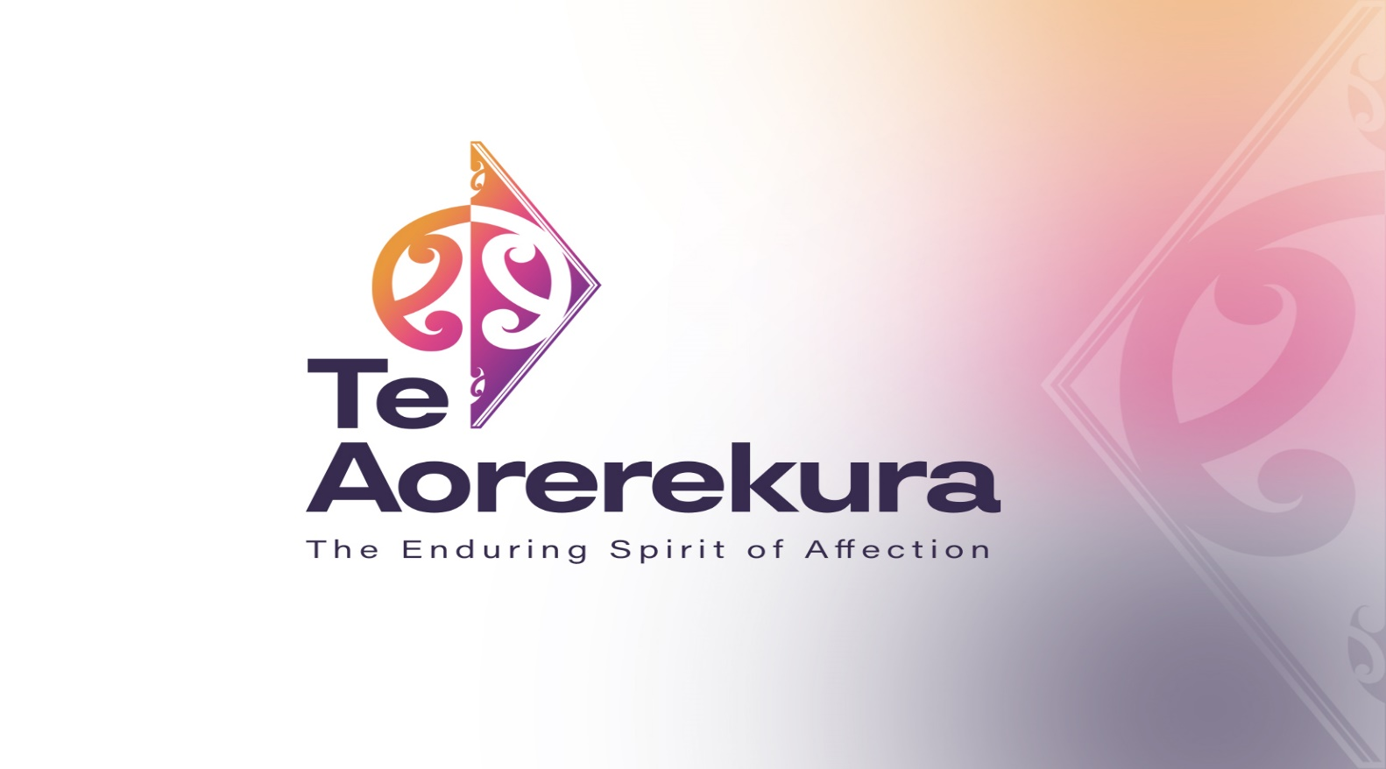

The National Strategy to Eliminate Family Violence and Sexual Violence

Te Aorerekura: the enduring spirit of affection

December 2021 Large Print Version
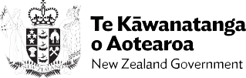

Minister’s Foreword
As the first Minister for the Prevention of Family Violence and Sexual Violence, I am honoured to introduce Te Aorerekura, our first National strategy to eliminate family violence and sexual violence.
Te Aorerekura sets a collective ambition to create peaceful homes where children, families and whānau thrive; to enable safe communities where all people are respected; and to support the wellbeing of our nation. It represents an evolution in our journey to address violence in our homes and communities.
Family violence and sexual violence are two of our nation’s greatest shames. The statistics alone create a frightening picture, made only worse when we consider the significant underreporting.
Violence and its harm transcends all communities, ethnicities and social classes. That is why Te Aorerekura recognises that it will take a generation to enable the social changes required to achieve our vision.
Te Aorerekura reflects the kōrero we have had with communities up and down the motu. It builds on the mahi of the countless people who have dedicated their lives to supporting those in crisis or improving the system.
I orea te tuatara ka puta ki waho

A problem is solved by continuing to find solutions

Hon Marama Davidson
Minister for the Prevention of Family Violence
and Sexual Violence

Executive Summary
Aotearoa New Zealand has high rates of family violence and sexual violence which cause harm and ongoing trauma to people, families, whānau and communities. Women, children and young people, tangata whenua, Pacific peoples, disabled people, older people, LGBTQIA+ communities, ethnic communities are disproportionately impacted.
Family violence is a pattern of behaviour that coerces, controls or harms, within the context of a close personal relationship. It includes intimate partner violence, elder abuse, child abuse, dating violence, stalking, and violence towards another family or whānau member, including child-to-parent violence, and can be physical, sexual, psychological, emotional, spiritual, or involve economic abuse or exploitation.
Sexual violence is any sexual behaviour without the other person’s freely given consent. Among other things, it includes child sexual abuse, sexual violation, incest, rape, assault, exploitation, trafficking, grooming, sexual harassment, and any unwanted kissing or touching.
The purpose of Te Aorerekura is to set out a framework to eliminate family violence and sexual violence, to drive government action in a unified way, and harness public support and community action. It will also increase political and public sector accountability by setting out what the government is committing to do and how it will measure and report on progress.
How does this Strategy address family violence and sexual violence?
Te Aorerekura sets a wellbeing and strength-based vision for eliminating family violence and sexual violence. There is a stronger focus on primary prevention, healing, and the critical role of tangata whenua and community leadership for achieving intergenerational change.
It identifies and responds to the factors that drive violence, requiring accountability from people using violence, and supporting them to change. Accountability is also required from those responding to violence, including government. Government has responsibility for keeping people safe and an important role to play through using institutional practices, policies and legislation to promote safety, equity and inclusion.
It acknowledges the complexity and diversity of the experiences of people, families and whānau and the different, timely responses and workforce capability required to meet their needs. It brings tangata whenua, communities, the specialist sectors and government together to regularly share knowledge and align actions.
The moemoeā (dream and vision) for change is that all people in Aotearoa New Zealand are thriving; their wellbeing is enhanced and sustained because they can live lives free from family violence and sexual violence.
The Strategy is guided by five principles – the whanonga pono – equity and inclusion, aroha, tika and pono, kotahitanga and kaitiakitanga. These will help shape the way every person and organisation works as part of Te Aorerekura. These whanonga pono informed the development of Te Aorerekura and will guide its implementation by:

  - Prioritising equity and inclusion in all spaces, ensuring equity of resourcing and outcomes; that all voices are heard and represented at all levels of decision-making; and that all people have options about the supports they receive.
  - Acting with aroha, recognising that treating people with kindness and care enables healing and demonstrates what respectful relationships look like.
  - All actions are tika and pono, where people act with fairness, integrity, and are accountable for their actions.
  - People work together in an integrated way, reflecting kotahitanga to provide support to others, and receive support in return.
  - Kaitiakitanga is practised – all people understand their roles and responsibilities to ensure the safety and wellbeing of people and their families and whānau.

Te Aorerekura is underpinned by and gives effect to The Treaty of Waitangi (Te Tiriti o Waitangi). The government’s legislation, policies and practices to eliminate sexual violence and family violence will align with the intent and articles of Te Tiriti.

Communities' needs and aspirations

Disabled people
“We want choices in quality services and supports that meet our needs”
We are diverse people. Even if we have the same impairment, we can have very different support needs. We experience violence in different ways and at higher rates than other groups.

Women impacted by violence
“We want to be believed, safe and protected when we reach out for help.”
We are disproportionately impacted and wāhine Māori are impacted the most. We need easy access to specialist support for ourselves, our families, whānau, children and young people.

Children and young people
“We need love and support to feel safe at home and in our communities.”
We need you to know we experience sexual abuse, regardless our gender, identity, ethnicity or social background. We want to be listened to and believed. We need to be at the centre of systems.

Men impacted by violence
“We need services that are designed for us.”
Many of us are impacted by family violence and sexual violence as children or young people, but there are few support services for boys and young men. We, as adult male survivors, feel invisible.

People who use or have used violence
“We want help early from people we can relate to and trust."
As soon as we display troubling behaviours, when we’re young, or as soon as we’re ready to get help, we need support to understand and change our behaviour. We know we need to take responsibility.

Tangata whenua
“Our toiora is intrinsically linked to whānau ora.”
We want to focus on whānau ora. We want our tikanga, reo, kawa and mātauranga Māori to be the pou for realising whānau ora. We want to receive the resources and decision-making power promised us under Te Tiriti o Waitangi.

Pacific peoples
“Our communities are built on family, faith and culture.”
Faith, family and cultural values create resilience for Pacific communities. We need to be involved in developing and delivering services for our communities.

Older people
“We need family and carers to be safe and treat us with respect”
The violence we experience is often not visible because of poor health, disability or being dependent on others, or social isolation. We need people to understand the specific violence that happens to us.

Ethnic communities
“We want safe responses that understand our cultural diversity and experiences”
We want better data on the distinctive forms of violence we experience, such as dowry-related violence, and control of visa/immigration status and finances.

LGBTQIA+ communities
“We want an end to discrimination, stigma and exclusion.”
Discrimination and stigma drive violence towards LGBTQIA+ people – at home, at school and in the community. Discrimination causes psychological distress and stops us seeking help. When we do seek support, responses often take a binary gendered and heteronormative view.

The Six Shifts and their Actions
Evidence and community feedback indicate that achieving the moemoeā and tukunga iho (outcomes) will require six shifts in how tangata whenua, specialist sectors, communities and government work together.

Shift One: Towards strength-based wellbeing
Adopt a strength-based wellbeing approach that will integrate all aspects by adopting the Tokotoru model with a focus on changing the social conditions, structures and norms that perpetuate harm.
The government recognises its accountability for achieving ora and safety and Te Aorerekura sets out an approach for all people to work together to enhance wellbeing through the elimination of family violence and sexual violence.

The Tokotoru model – what is it?
Tokotoru – meaning the ‘unbreakable three’ – is a whānau-centred model that outlines the three dimensions that enable and enhance wellbeing – strengthening, responding and healing. The interconnectedness of all three dimensions emphasises the need for a holistic approach.
At its heart, the shift to the Tokotoru model indicates the government’s ongoing commitment to changing the social conditions, structures and norms that perpetuate harm.

Actions for Shift One:
Action 1: Te Aorerekura is supported by a clear investment plan.
Action 2: Agencies integrate community-led responses.
Action 3: Strengthen wāhine Māori leadership.
Action 4: Wāhine Māori leadership succession.

Shift Two: Towards mobilising communities
Mobilise communities through sustainable, trust-based relationships and commissioning decisions that are grounded in Te Tiriti and sharing evidence on what works.
This is about high-trust, collaborative and respectful relationships between tangata whenua, central and local government, the specialist sectors, communities to build collective ownership for solutions, and support and resource integrated, community-led responses. This shift is about stronger relationships that enable better design, delivery and learning.

Actions for Shift Two:
Action 5: Engage and value communities in collective monitoring, sharing and learning.
Action 6: Relational approach to commissioning to better support community decision-making and needs.
Action 7: Enable Te Aorerekura implementation in the regions.
Action 8: Establish a Ministerial Tangata Whenua Advisory Group.
Action 9: Establish an annual Te Aorerekura hui.

Shift Three: Towards skilled, culturally competent and sustainable workforces

Ensure the specialist, general and informal workforces are resourced and equipped to safely respond, heal and prevent and enable wellbeing.
The needs of different communities to respond to and prevent family violence and sexual violence vary greatly. To ensure protection, accountability, healing and restoration, we need specialist and general workforces and informal networks that can provide safe, appropriate and effective responses across a range of communities. Currently, there are not enough people able to provide the right help.
Specialists, generalist, and informal networks all require different resources, tools and opportunities for upskilling. The organisations they work for need policies and practices to support effective, consistent responses. A long-term approach to building and retaining diverse, sustainable and competent workforces is needed.

Actions for Shift Three:
Action 10: Develop and implement trauma-informed family violence and sexual violence capability frameworks for specialist workforces.
Action 11: Agencies implement capability frameworks for generalist workforces.
Action 12: Build tools for informal helpers.
Action 13: Invest in upskilling community primary prevention.
Action 14: Build the specialist workforces for children.
Action 15: Build court workforce capability.

Shift Four: Towards investment in primary prevention

Invest in a unifying, Te Tiriti-based primary prevention strengthening model that protects against family violence and sexual violence.
This Shift focuses on collective investment in changing environments, attitudes, behaviours and norms through a range of integrated actions. It is about enhancing and scaling what works. Prevention initiatives have often been led by single government agencies, and that reduces their effectiveness. A unified approach will make initiatives more impactful. Te Aorerekura is signalling a deliberate investment strategy to lift the proportion of funding that goes into prevention initiatives.

Actions for Shift Four:
Action 16: Adopt the Primary Prevention System Model.
Action 17: Develop tools to support healthy, consensual relationships for young people.
Action 18: Refresh the health and physical education curricula.
Action 19: Develop the Oranga Whakapapa programme.
Action 20: Develop community mobilisation infrastructure to lead sexual violence primary prevention.
Action 21: Deliver proud as well as for other population groups, including older people prevention initiatives: Campaign for Action on Family Violence, E Tu Whānau and Pasefika.
Action 22: Develop and deliver a sexual violence primary prevention campaign for Māori and Tauiwi.
Action 23: Develop prevention programmes for ethnic communities.
Action 24: Holistic support for safe early years.
Action 25: Develop social and emotional learning for children.
Action 26: Strengthen community-led solutions to prevent child sexual abuse.

Shift Five: Towards safe, accessible, and integrated responses
Ensure accessible, safe and integrated responses meet specific needs, do not perpetuate trauma, and achieve safety and accountability.
Increased efforts to eliminate family violence and sexual violence through Te Aorerekura will mean more people are likely to seek help.

Te Aorerekura establishes an ongoing commitment to safe, integrated services that meet the holistic needs of those impacted by violence, and supports accountability and behaviour change for people who use violence.
Te Aorerekura also commits to work towards what some communities refer to as the ‘twin-track approach’. Firstly, all family violence and sexual violence response services and supports must be inclusive and accessible to all. Secondly, we will work to provide a wider range of specialist services developed by and for different communities.

Actions for Shift Five:
Action 27: Develop new practice guidelines for participants in court proceedings.
Action 28: Implement safeguarding responses for disabled and vulnerable adults.
Action 29: Develop a plan to fill the service gaps for family violence.
Action 30: Develop a plan to fill the service gaps for sexual violence.
Action 31: Develop a case management system for family violence responders.
Action 32: Improve the Family Start service.

Shift Six: Towards increased capacity for healing
Increased capacity for healing to acknowledge and address trauma for people and whānau.

The trauma of those impacted by violence is ongoing. Te Aorerekura sets out the need for more appropriate, tailored, specialist and whānau-centred healing, recovery, and restoration services to address the intergenerational trauma of childhood exposure to family violence and sexual violence.
Until people can heal and restore, violence and trauma continue to affect them. Direct experience of violence, or exposure to it, has negative impacts on children and young people’s health, education, social development, personal relationships, and future economic wellbeing. The harm can be compounded as children and young people transition into adulthood.

Actions for Shift Six:
Action 33: Undertake an analysis of healing services and responses to determine gaps and opportunities.
Action 34: Develop training and resources for parents, caregivers, and whānau.
Action 35: Design local tangata whenua services for sexual violence healing and restoration.
Action 36: Extend and expand whānau-centred initiatives.
Action 37: Extend and expand whānau-centred early intervention.

Learning and Monitoring Progress
The initial Action Plan sets out specific, short-term actions for the next two years, and will be reviewed and refreshed annually.
To measure progress towards achieving the Six Shifts a range of measures will be needed. These measures will be developed collaboratively with tangata whenua, communities, and the specialist sectors so we create a framework that measures what matters and can track progress towards eliminating family violence and sexual violence.
We know there are gaps in our data collection on family violence and sexual violence. This will help fix them.

Actions for Learning and Monitoring Progress
Action 38: Continuously develop and improve the learning system through the collection of evidence and voices.
Action 39: Work together to finalise measurement framework.
Action 40: Invest in monitoring and learning to build the evidence base for primary prevention.

Impacts to be measured

Tukunga iho – Outcomes
  - Haumaru – People are safe and protected
  - Whakawhirinaki – People with a network of trusting relationships
  - Mana motuhake – People have autonomy and freedom of choice
  - Ngākau whakautu – People are respected for who they are
  - Tūhono – People are connected with others who support their wellbeing
  - Poipoi wairua – People are nurtured and cared for

Impacts we will measure for the experience of the system for all people:
Prevalence and reporting statistics including across different communities will be measured by how:
  - Children and young people understand healthy relationships, how to seek help, and can access tailored services.
  - Individuals and whānau are supported to heal and overcome the trauma of violence.
  - Participants in the Justice system are protected, safe and supported.
  - Reduced tolerance for violence and inequity across Aotearoa New Zealand.
  - Women, wāhine Māori and others impacted by violence access integrated and inclusive responses to enable safety.
  - Tangata whenua, Pacific peoples, ethnic communities, LGBTQIA+ communities, older people, children and youth, and disabled communities can access tailored services.
  - Those that use violence are accountable and supported to change.
  - Families, whānau and communities take action to prevent family violence and sexual violence.

Impacts we will measure for the system we are building will be measured by:
  - Government commitment to addressing the underlying social conditions and norms.
  - Government and communities work better together
  - Alignment around primary prevention.
  - Communities design, lead and deliver solutions to affect change.
  - Skilled, culturally competent, and sustainable workforces
  - Joined-up and easy to navigate services.

Summary
All these shifts will be delivered through actions that are specific, time-bound, and resourced to strengthen how the government works and learns together with tangata whenua, communities and the specialist sectors to achieve the tukunga iho (outcomes).
Te Aorerekura is a 25-year Strategy because it will take a generation of sustained investment and focus to strengthen the protective factors and enable the social changes required in Aotearoa New Zealand. However, we will look for tangible improvements as the Strategy is implemented.
Te Aorerekura signals an intergenerational journey towards wellbeing. This means that we don’t set off with all the answers. Alongside the six shifts, we need to develop a system that learns, so that as more data, research and evidence is developed, it can be shared and built on to improve practice and ultimately eliminate family violence and sexual violence in Aotearoa New Zealand.

