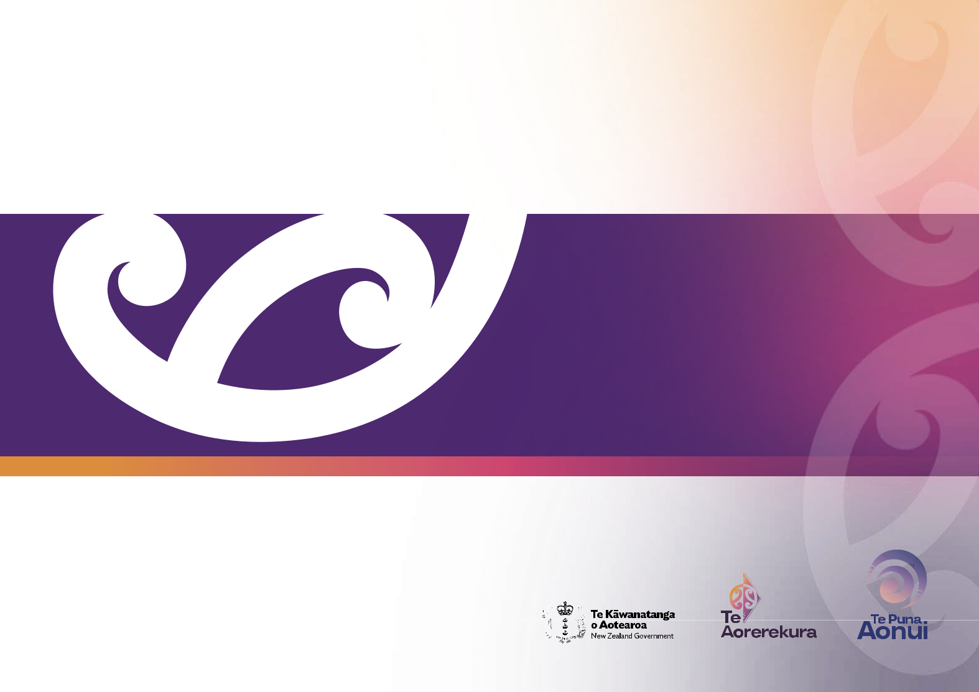

2022 Te Aorerekura
Annual Hui Report

Publisher

Te Puna Aonui – the Joint Venture for

the Elimination of Family Violence

and Sexual Violence

ISSN 2815-9799

Contents

Annual Hui Report | 3
Minister’s foreword | 4
Te Aorerekura Annual Hui 2022 | 7
Theme: Addressing inequities | 8
Theme: Tangata whenua leadership | 12
Theme: Activating the power of communities | 16
Theme: Working together and strengthening relationships | 20
Theme: A shared pathway forward | 24
There is strong commitment and an appetite for change | 28
How you can support the kaupapa | 31
Next steps and Hui 2023 | 32

1

Ka pō, ka pō, ka ao, ka awatea. Tīhei mauri ora ki te whei ao!

Tihei mauri ora ki to ao mārama!

The first rays of dawn herald the transition from night to day.

Behold it is the living environment! Behold it is the world of light!

2

2022 Te Aorerekura
Annual Hui Report

Te Puna Aonui – the Joint Venture for the Elimination of Family Violence and Sexual Violence hosted the inaugural Te Aorerekura Annual Hui online on 27-28 July 2022. This report identifies the key themes and messages from the Hui, which will help guide the next Action Plan and planning for the 2023 Hui.

Te Aorerekura – the National Strategy to Eliminate Family Violence and Sexual Violence was released in December 2021. It is a strategy for all of us, and we all have a part to play in delivering its potential and promise.

Te Aorerekura and the Action Plan set out a new collective path for government, tangata whenua, specialist sectors, and communities. For this reason, the Hui focused on creating a sound platform for working together across the sectors, building relationships and awareness of Te Aorerekura, and reflecting on those who have been impacted by violence.

The purpose of this year’s Hui was “together reflect on progress towards the Shifts in Te Aorerekura and what we are learning” along with the themes of accountability and transparency.

The Hui delivers Action 9 of the Action Plan and represents an enduring commitment to government engaging with tangata whenua, communities, and the family violence and sexual violence sectors. The Hui enables us to come together, take stock of progress, share learning and experiences, and shape what happens next. Lessons, themes, and information from each Annual Hui will contribute to future updates of the Action Plan.

A copy of the Hui programme is here.

3

Tēna koutou katoa,

We have a bold vision. It’s that all people in Aotearoa are safe, thriving and supported to live free from family violence and sexual violence.

This won’t be easy. It means a huge change to the way we’ve done things in the past.

It means moving towards prevention, real accountability from people and agencies who cause harm to survivors, and long-term healing for all of those who suffer the impacts of violence.

Launched in December 2021, Te Aorerekura the National Strategy to Eliminate Family Violence and Sexual Violence laid out the pathway and mandate for lasting, generational change. The aroha and insights of our specialist sectors, tangata whenua, government agencies and the diverse communities of Aotearoa, shaped its vision and direction – and it will be up to all of us to bring it to life.

Supporting the strategy is an initial two-year action plan and I am proud to say we are already underway on all 40 actions. The inaugural Te Aorerekura Annual Hui in July 2022 signposted another action and it was an unforgettable milestone in our journey to a more peaceful Aotearoa.

I was incredibly humbled to hear and see so many different groups, communities, agencies, Ministers, leaders and providers, who are already embracing Te Aorerekura, speak about their challenges, successes and hopes for the future.

4

Our theme for the Hui was accountability. As we all know, strategies and plans have to be more than just words on a page. Our success depends on government, community and sectors coming together to take stock of progress, and to listen and learn from one another.

What was clear is that we must keep having hard conversations and challenging out-dated ways of working that continue to harm people impacted on by violence. Being prepared to do things differently is where the real hope lies, and where we must head if we want better lives for our grandchildren and mokopuna.

During the Hui, communities told us they are ready to do the mahi and bring Te Aorerekura to life in ways that reflect and uphold the uniqueness of their people and regions. What they need from government is to work at pace with flexibility and trust, and to put families and whānau at the centre of the work.

This change is happening, and we need to see more of it. You have my commitment as Minister for the Prevention of Family and Sexual Violence, to continue working with my colleagues and agencies to drive a less siloed, more innovative way of working so we can better support your work in the communities.

Throughout this report, you’ll see where we still have lots of work to do and hear insights from our experts on how we can get there.

Eliminating family violence and sexual violence requires that we grow the conditions for wellbeing so families, whānau and communities have what they need to flourish. It also means changing social norms and attitudes, no longer tolerating gender-based violence and attitudes that allow the misuse of power. Action is required at every level of government, in communities, in our homes and in our hearts.

We should not understate or underestimate the power we have if we move together.
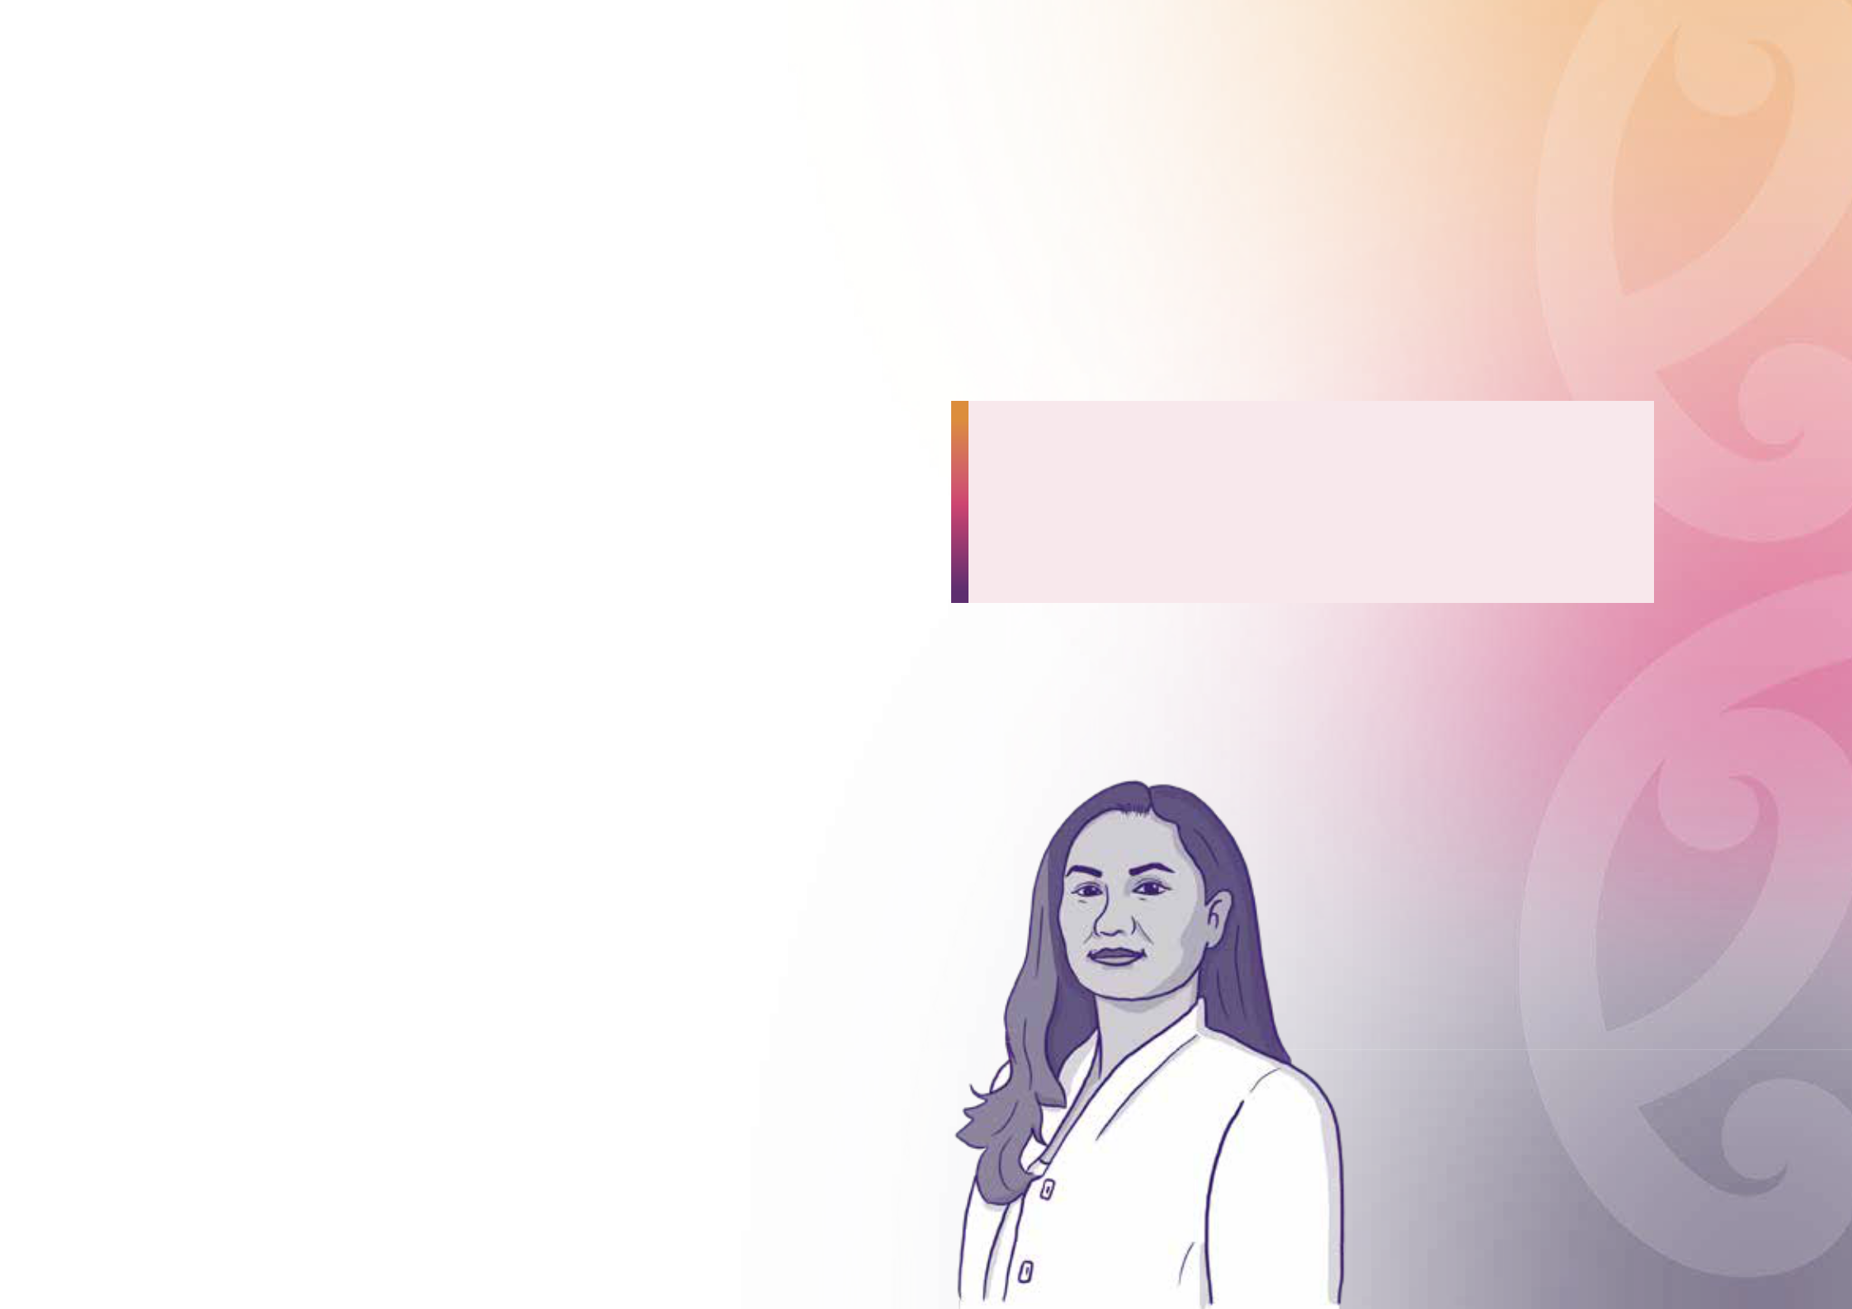

Te Aorerekura belongs to all of us, and I urge you all to take hold of it.

Ka pō, ka pō, ka ao, ka awatea.

Tīhei mauri ora ki te whei ao!

Tihei mauri ora ki to ao mārama!

The first rays of dawn herald the transition from night to day. Behold it is the living environment! Behold it is the world of light!

Ngā mihi,

Hon Marama Davidson

Minister for the Prevention of Family and Sexual Violence Minita mō te Ārai i te Whakarekereke Whānau me te Koeretanga

5

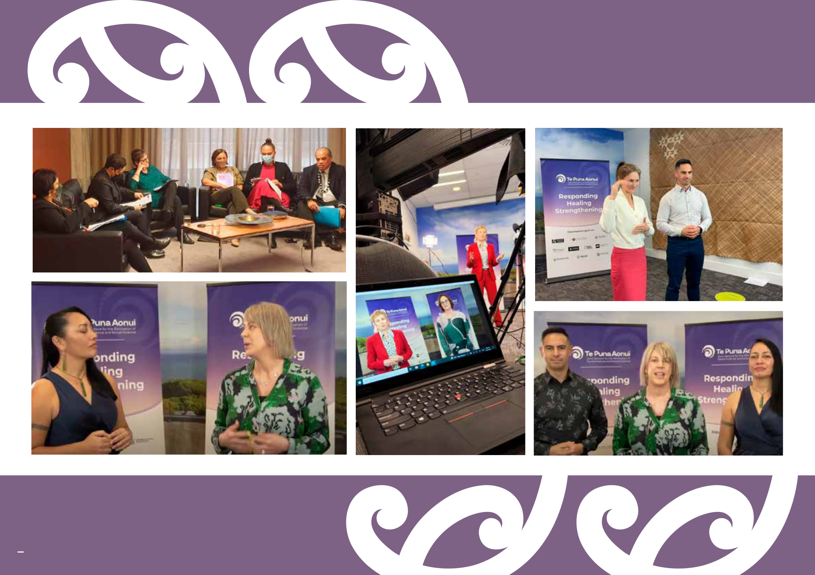

2

6

Te Aorerekura Annual Hui 2022

Te Puna Aonui – the Joint Venture for the Elimination of Family Violence and Sexual Violence hosted the inaugural virtual Hui on 27-28 July 2022.

The Hui attracted people from government, sectors and communities

Important themes emerged in the 2022 Hui

Across the Hui sessions, the common themes can be summarised as:

THERE WERE

963
registrations

for the event

60%
were sector and community

representatives

4%
were academics

36%
were government agency representatives

 |  | Tangata |  | Activating |  | Working |  | Working
Addressing |  |  |  |  |  | together and |  | towards a
 |  | whenua |  | the power of
inequities |  |  |  |  |  | strengthening |  | shared
 |  | leadership |  | communities
 |  |  |  |  |  | relationships |  | pathway

Te Aorerekura sets a pathway

Participants were asked to indicate whether they agree that:

Attendance₅₇₁peakedat

individual connections
at any one time

849

individuals attended
Day 1 of the Hui

572

individuals attended
Day 2 of the Hui

“Te Aorerekura sets a pathway for how tangata

whenua, communities, the specialist sectors, and
government can work together to eliminate family ^{3.77} violence and sexual violence over a generation”.

Out of a score of 5 (1 being strongly disagree, | 0 | 5
5 being strongly agree), the average score was 3.77.

The two days were split into the six Shifts within Te Aorerekura, including discussion panels, as well as a focus on learning and monitoring.

We explore those themes in more detail throughout this report. You can also watch all of the discussions and panel sessions from the Hui by visiting tepunaaonui.govt.nz

7

Theme:
Addressing inequities

The underlying causes of family violence and sexual violence are

exacerbated by the inequities that exist in society. A common thread

through Hui presentations was the need to create equity and enable

the conditions for wellbeing, to reduce the likelihood of violence.
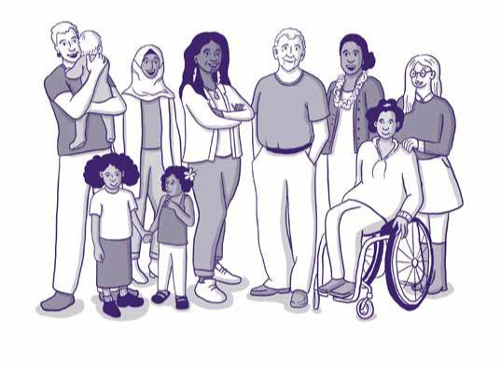

Areas of focus included:

Social and economic inequities experienced by individuals and whānau can contribute to the prevalence of family violence and sexual violence. Ensuring people have what they need to live good lives is one of the preventative factors to mitigate drivers of violence – while at the same time we know that violence happens across all communities.

Participants talked about some of the whānau they supported not having access to adequate food, housing, or clothing, and the impact this can have on children.

Not having access to the basics needed for health and wellbeing can contribute to stress, violence, and behaviours that isolate and harm people. Participants highlighted that gaps in services and responses, and government failure to protect people, have entrenched inequities across communities.

Outgoing Director General of Health, Dr Ashley Bloomfield, spoke about what he had learnt through the COVID-19 response. He said the best way to prepare for the next pandemic and ensure health is to address inequalities. Minister for the Prevention of Family and Sexual Violence Marama Davidson also acknowledged this and observed that addressing inequities is one of the main ways to deal with the crisis of violence.

8

When government privileges a Western or Pākehā world view, it misses opportunities for effective responses. Participants repeated that government should value the specialist knowledge and experiences tangata whenua, sectors and communities bring, and work together to enable iwi and community-led approaches.

Participants communicated they are often battling the internal mindset, policies, and procedures within government agencies but, “communities know best what will work for them”. Ngā Kaitiaki Mauri, of TOAHNNEST1, reiterated that the content of their kaupapa Māori Sexual Violence Good Practice Principles, for example, may seem innovative but are based on ancient knowledge – mātauranga – and has been collected for years and embedded in te ao Māori practices.

There are inequities for communities who do not have access to adequate support and services, and they want to be involved in developing appropriate supports for themselves. Members of the disabled community talked about a twin-track approach to ensure equitable access to the right services and support for them. Safeguarding Adults, a multi-agency response to enable disabled people to live lives free from harm, abuse and neglect, was one of the promising examples discussed.

There are also regional inequities that need to be addressed as some towns and rural areas are under-served. For example, Rural New Zealand noted crisis response services in rural areas can mean waiting hours for help to arrive. During the Ministers’ panel, Hon Priyanca Radhakrishnan noted how family violence and sexual violence presents in different communities and the importance of knowing and understanding ‘one size doesn’t fit all’.

1 TOAHNNEST is Te Ohaakii a Hine – National Network Ending Sexual Violence Together.

9

Equality of decision making is important for tangata whenua, communities, and specialist sectors to work with government, and is also important within families and whānau. Some participants spoke about the need for communities to be at the decision-making table. For example, the South Auckland Social Wellbeing Board spoke about the need to ‘reverse engineer’ the system to go beyond whānau voice and to put whānau in the driver’s seat. This would involve more decision making and resourcing at a local and hapori level to reorganise services around how people live their lives. They have seen that government working with iwi, hapori and communities to strengthen whānau, shifts the current power dynamic in positive ways.

Racism, sexism, ableism, and bias must be eliminated within agencies and workforces. Participants highlighted how government and mainstream services can lack cultural capability and need to upskill so that they can meet the diverse and specific needs of the communities that come through their organisations and systems.

Participants heard about how the recently released Family Violence Workforce and Organisational Capability Frameworks are intended to support workforces, including government, to gain an understanding and analysis of the role power and inequality play in perpetuating violence, as well as educating people on how to reflect on their own biases to ensure their responses are always safe, respectful and culturally appropriate. For example, Ara Poutama discussed the essential family violence knowledge and skills needed for different roles and responsibilities within their organisation.

Working towards achieving equity and equality in relationships is a key form of violence prevention. Le Va presented an example of primary prevention work within Pacific communities and programmes for men based on Pasifika values (the Fathers’ Fono which creates a ‘village of dads’ and a safe space to learn about fathering), and the Atu Mai Upstander campaign (which supports Pacific youth to take a stand against violence in safe way).

To sum up

The Hui participants recommended an equity lens is applied to all family violence and sexual violence work. This includes improving strengths-based and holistic responses that are tailored to the needs of different communities, along with efforts focused on communities who have been the least-served in the past.

10

11

Theme:
Tangata whenua leadership

Te Aorerekura charts a pathway towards collective action embedded in strong and positively evolving relationships, to reflect and uphold Te Tiriti o Waitangi. As outlined in the opening pages of Te Aorerekura, “Te Aorerekura is underpinned by and gives effect to Te Tiriti o Waitangi. The government’s legislation, policies and practices to eliminate sexual violence and family violence will align with the intent and articles of Te Tiriti.”

The Hui reinforced the critical importance of government further evolving relationships with tangata whenua. Areas of focus included:

The importance of acknowledging that the majority of systems, processes and structures reflect a Western or Pākehā worldview. By acknowledging and challenging these world views, space can be created for other perspectives and paradigms. The Tangata Whenua Ministerial Advisory Group (MAG) noted, “...whānau Māori need something different around systems – how we think differently”.

The MAG panellists also noted, “...the urgency and priority around this mahi, after the past 30 years of Pākehā, Western [thought], I am excited that now our own ways, mātauranga, are coming to the forefront”. Systemic privilege also aligns with the inequities theme because both mean we miss opportunities for effective responses.

“Whānau Māori need something different around systems – how we think differently”.

Space needs to be created for te ao Māori, mātauranga, whānau and community-led approaches. The development of the Family Violence Workforce Capability Frameworks was highlighted as an example of where an indigeneity lens (Te Tiriti o Waitangi, te ao Māori and whānau-centred thinking) had been used to develop a framework. Another good example of how to avoid the automatic application of a Western approach is Safeguarding Adults from Abuse (SAFA) – which is being evaluated using a kaupapa Māori approach.
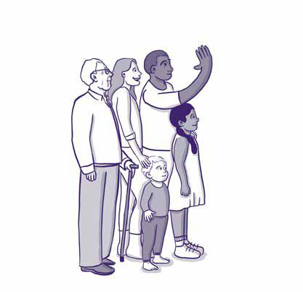

12

The importance of a whānau-centred approach, whānau-centred thinking, and the space for whānau to lead action to address family violence and sexual violence in a way that is appropriate to them. Many speakers noted solutions needed to fit with “...whānau in all their diversity.” Across Aotearoa and within iwi, one size does not fit all.

The relationship between tangata whenua and government needs to evolve to higher trust and value including devolution of resources, systems and processes. Speakers highlighted Te Tiriti breaches, failures to protect, neglect, racism, and abuse at the hands of the State and said the harms of colonisation and its ongoing impacts must be recognised as part of healing for victim-survivors and achieving lasting change.

A deeper relationship includes the broadening of perspectives for cultural frameworks, acknowledgement and inclusion of mātauranga Māori solutions; and independence and ownership (such as data sovereignty).
An observation during one presentation centred on the value and trust aspects of relationships: “Respect plays a big part: that is recognition, appreciation and support diversity and dynamics [sic].”

The impact of issues that encompass family violence and sexual violence, but also that have fundamental wellbeing aspects. The Hui acknowledged the need for work to address colonisation and its impacts, along with wider societal factors such as poverty. The importance of taking a holistic approach was emphasised throughout the two days.

At the most basic level – across work and all sectors – there’s a need for culturally competent services, especially building and applying cultural safety into mainstream services so they can be safely accessed by Māori, when Māori need them.

“Don’t apportion people’s lives into tiny bits”.

“Is there such a thing as systems change without looking at the basics – housing, kai?”

13

Acknowledgement and understanding of whakapapa perspectives was also raised during the Hui. The importance of acknowledging and understanding whakapapa perspectives. Intergenerational impacts and outcomes were reinforced in discussion about the long-term focus of Te Aorerekura to break cycles, with a need to reinforce a strength-based focus on tamariki wellbeing.

“We have to get hold of the harm being done to our mokopuna, to our tomorrow’s fathers and tomorrow’s mothers.”

“Tamariki are our future leaders”.

Te Puni Kōkiri outlined their work to put whānau wellbeing at the centre – with communities leading, designing and delivering change when empowered and resourced to. This is “putting whānau at the centre and recognising they have the solution”.
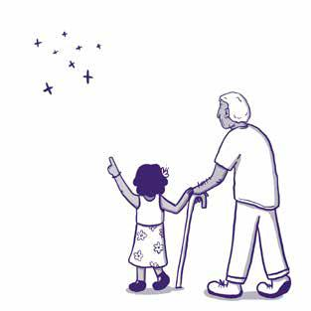

The Tangata Whenua Ministerial Advisory Group (MAG) also hosted a session during the Hui, to share their role and what they are seeing within the system from a tangata whenua perspective. The key messages from the MAG to participants during the Hui included:

Mana and the importance of understanding what has happened to mana over time – how to enhance mana, understanding the birth and the inherent mana of the baby. There was discussion about the role of Te Aorerekura in changing and enhancing mana with te ao Maori – through the Shifts and alongside the healing journey.

The importance of whānau, hapū, and iwi having their own solutions to addressing violations of whakapapa. “Māori have the solutions, how we can make some shifts… they know how things could be different for them, they just need the conditions to shift for them.”

The Tangata Whenua Ministerial Advisory Group (MAG) described their accountability to the Minister and also to “those we have lost and harmed...

to whānau, hapū and iwi in these positions… be accountable to ourselves to continue this important mahi.” The MAG is an independent advisor to the Minister and will also create space and opportunity to represent whānau in all of their diversity across the motu. MAG members likened their work to ringa raupa – the calloused hands that are committed to the people.

14

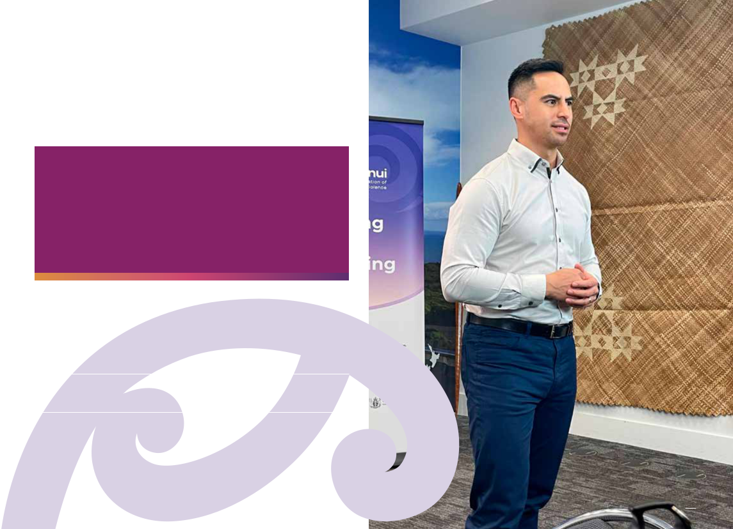

To sum up

It was clear over the two days of the Hui that there was a deep

commitment across many working in the system to embed and reflect

te ao Māori, and Te Tiriti in work and activities to eliminate family violence

and sexual violence. Feedback received after the Hui indicated that it

would be good to hear more detail about how actions are centred in te ao

Māori, and share success to demonstrate how this is working.

E tio te tūī, e ketekete te kākā, e korihi te kokako It takes many instruments to make a symphony

15

Theme:
Activating the power of communities

In the context of Te Aorerekura, communities are defined as groups of peoples who live in the same place or have identities or shared interests. The focus on communities in Te Aorerekura is to hear the view of those most impacted by family violence and sexual violence. Hui participants asked for communities to have greater ownership of, and input into, government strategies, policy reform work, actions and decisions affecting them.

Many presentations focused on activating the power of communities. The Hui heard that to get real traction and step change, there is a need to activate the power of communities to contribute to the Shifts in Te Aorerekura.

Equip communities with tools, information, and the capability they need.

Communities require relevant information, tools and capabilities to be trusted first responders who can enable people to access services and government agencies for further assistance. Some communities have established a network that feeds into government advice around family violence and sexual violence that relate specifically to that community. The Rainbow Violence Prevention Network is an example of this. The advice they provide ensures LGBTQIA+ people’s needs are represented and accounted for. Communities rallying together to ensure the diversity of their voices are represented in solutions is vital for government and communities to address the inequities and inequalities within communities.
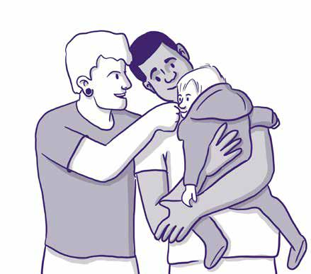

16

Share lessons to see improvements. Platforms for engagement between communities, service providers and government agencies will enable timely insights on emerging opportunities and risks, and support people to participate in test and learn processes. Action 5 (Engage and value communities in collective monitoring, sharing and learning) in the Te Aorerekura Action Plan provides for people and communities impacted by family violence and sexual violence to have a respected, ongoing role to share experiences and learning to guide government’s work programme and monitor the implementation of Te Aorerekura. For example, ethnic communities are in the process of establishing

a network of family violence and sexual violence providers and community members that work closely with people impacted by violence to advise on the work government will be doing to eliminate family violence and sexual violence.

Communities want to actively participate and be involved early. There was a focus on the importance of shared leadership, co-development and co-design as we implement Te Aorerekura. Ministers spoke of “ensuring survivors are leading the way... [and]... a victim-centred approach”. Minister Allan also noted the call for more “wrap-around support as people go through the system”, and talked about upscaling things that have worked in places before, e.g., Family Court Navigators.

Space for communities to lead, develop and drive their own programmes of work, relationships and aspirations. Drawing on the experience of devolving resources and decision making during the COVID-19 pandemic, Ministers Sio and Sepuloni noted the impact of COVID-19 and the challenge to maintain devolved approaches and speed this up within the sector. Minister Sepuloni specifically noted the need to: “... talk to those working in the sector and ask what they need to respond effectively, then came in alongside and behind to support”.

17

An enhanced relationship with government to draw on the strength and knowledge of communities. The family violence and sexual violence sectors consist of organisations throughout Aotearoa that work with people who are impacted by violence. The sectors have organisations with specific needs, depending on who they cater for. To meet those needs, the sector set up the Systems Working Group which brings a mix of government agencies and members of the family violence and sexual violence sectors together each month. The meetings provide an opportunity to discuss needs and the ways in which government can help respond and remove barriers to progress. This is an example of an enhanced relationship that allows government and the community sectors to work together to understand where the gaps are and how to mobilise themselves to fix them.

People should be the centre of community-led activities. Many participants agreed that services should be organised around how people live their lives and not around administrative requirements. Services and supports need to recognise the lived experience of those who are impacted by violence or have caused harm. Minister Sepuloni noted that “...people are served better when community organisations and government agencies are working in-sync”.

Recognise the intersectional needs within communities. The community mobilisation panel spoke about cultural awareness and the importance of building trust and rapport. It’s important the community groups and organisations the government is learning from includes those working with intersectionality, to form relevant, nuanced advice.

The voices of children and people need to be heard and elevated within a family-centred approach. The panel focused on children and young people said young people have already told us what they want. We have seen a number of marches asking for compulsory education about consent, with the Youth Parliament and petitions asking for reform of consent law. More needs to be done to strengthen capability and engage with children and young people in the implementation of Te Aorerekura.

18

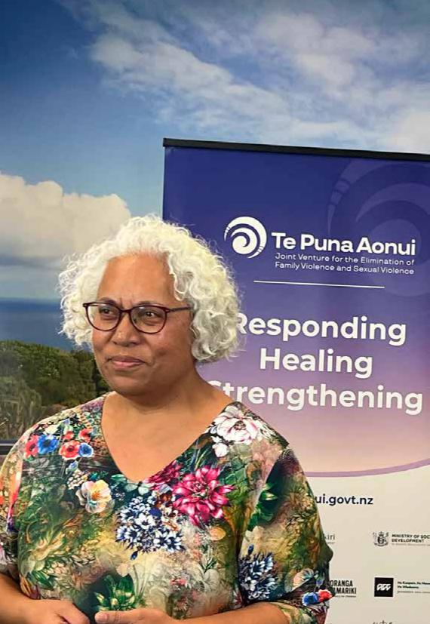

Support and enable us to activate the power of communities.

Multiple presentations from community organisations demonstrated the ways communities are working to ensure the needs of those they work with are met. The presentations at the Hui expressed the importance of community being at the centre of this work. Allowing communities to design solutions through appropriate resourcing allows them to be in charge of their own solutions. Minister Davidson said, “Te Aorerekura belongs to the people and needs to be protected and nurtured regardless of government and Ministers.”

To sum up

Communities have already started mobilising themselves to ensure they are actively involved in Te Aorerekura and are leading the way in changing the narrative on violence in some communities. Examples of programmes for men and for young people, based in their own cultural context and using peer to peer support, were demonstrating the value of working with people to give them the knowledge and tools they need to live free from violence.

Theme:
Working together and strengthening relationships

Throughout the Hui participants highlighted the importance of people coming together to achieve the vision of Te Aorerekura, with mana-enhanced, trusting relationships at all levels, that are focused on people and values. Working together better and strengthening relationships is prominent throughout Te Aorerekura. Many of the actions within the Action Plan require government, communities and sectors to work together to implement the Actions. The relationship between communities and government is still at an early stage.

Ensuring communities, sectors and government are building and strengthening relationships allows for a shared understanding and implementation of Te Aorerekura. Areas of focus in the Hui included:

A relational approach as an important foundation. Throughout the Hui we heard that efforts to prevent, heal and respond to family violence and sexual violence all require a foundation of strong respectful relationships, shared values, trust, reciprocity, and open communication.

Many participants named the ‘relational approach’ as being central to family violence and sexual violence work – this is about how we treat each other, putting people, relationships, and connections first, and starting from there. A relational approach is good practice when supporting individuals, whānau and families. It is also critical in relationships between government, tangata whenua, specialist sectors and communities. Te Puna Aonui shared information about the Family Violence Workforce Capability Framework, where a relational approach and ‘whanaungatanga’ are identified as core principles for anyone working in the family

violence space. A core skill is being able to build effective, meaningful relationships and protect safe connections between people.

Government needs to share resources and decisions. Some participants identified that stronger relationships will be enabled when there is a devolution of power. This involves enabling more decisions to be taken by communities, increasing funding for tangata whenua and communities, while government retains clear responsibility for improving what government is accountable for delivering. Several participants reminded us that during the national COVID-19 response, we prototyped stronger collaboration, high trust, flexibility, speedy decision making, and local leadership. It worked well for many and now people want to see that become part of everyday ways of working.
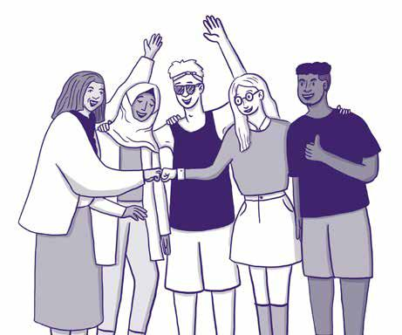

20

More support for local and regional networks. Several of the presentations demonstrated the advantages of collaborations, rōpū and networks. There were good practice examples of place-based, multi-sectoral collaborations where different organisations and groups come together with a shared kaupapa and to strengthen networks of specialist services for identified communities.

The Systems Working Group (SWG) consists of a network of family violence and sexual violence service providers that work alongside government agencies to co-design solutions that address and fill system gaps. This is beneficial for both sector and government as it allows for real time solutions and gives government an insight on the gaps in the system that can inform work programmes.

Relational commissioning. A common theme was support for relationship-based commissioning and impatience from communities who are wanting to see this form of commissioning in action. The call for a relational approach to commissioning comes from sectors that are specialists and should be trusted to deliver for the communities they serve. Instead, within non-government organisations (NGOs), too much time is being spent bidding for contracts, splicing together multiple funding streams to build a holistic service, and then reporting back for each of the different funding sources. This is time and labour intensive and takes staff away from their core roles.

Action 6: Relational Approach to Commissioning to better support community decision making and needs, centres on developing what’s required for relational commissioning of family violence and sexual violence services. Participants also called for disruption of the status quo to allow new perspectives to be brought to the table, to make space for change to take place with manaaki, empathy and compassion.

21

The importance of respectful relationships. A successful example of responding to whānau in South Auckland described the journey towards a joined-up response to family violence, led by whānau and communities, regionally enabled and nationally supported. This highlighted the respectful relationships we need
in this mahi, honouring the relationship with mana whenua, sharing power, and listening to each other. Presenters talked about the need to reorganise services around how people live their lives, and strengthen community connections so whānau support each other.
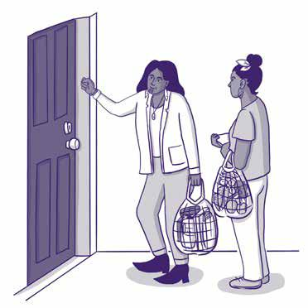

To sum up

Relational ways of working are critical within the family violence and sexual violence sectors. Relational approaches are about respectful, mana-enhanced relationships of trust, shared power and decision-making and can involve devolving resources and structures to locality level.

Relational approaches are essential when working with individuals, whānau and families impacted by violence, and increasingly important for how people work together within communities, within and across government, tangata whenua, specialist sectors and communities. Stronger relational ways of working will allow for quicker real-time action, and can put people at the centre of services, rather than piecemeal or siloed services, funding, and programmes.

22

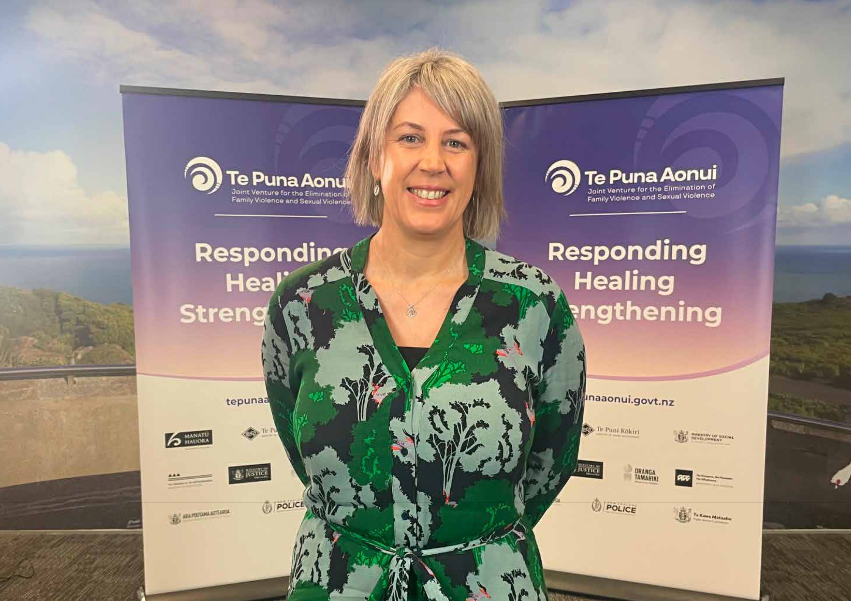

23

Theme:
A shared pathway forward

Te Aorerekura was created with tangata whenua, the specialist sectors, Pacific peoples, ethnic communities, LGBTQIA+ and disabled communities, people impacted by family violence and sexual violence, and the agencies of Te Puna Aonui. The Strategy belongs to us all and creates shared accountability for the elimination of family violence and sexual violence.

Key points in the Hui emphasising the importance of a shared pathway forward included:

Everyone has a role to play – and with such a complex and significant social change, step change will only be achieved if our actions move us in the same direction. Examples shared during the Hui were:

- ACC noted, “A cross-system approach to enable primary prevention at scale is needed – not single focused programmes – we need to be able to see inter-relationships and interdependencies.”

- South Auckland Social Wellbeing Board (Ann Wilkie) said, “Family violence is everyone’s business. Complex and underlying”.

- The Tangata Whenua Ministerial Advisory Group identified the need for, “access to all systems so whānau can have whānau ora. There is a real big emphasis on government agencies working together in order for a better future”.

- The panel focused on children and young people (Judge Frances Eivers) expressed the need to put solutions back with communities.

“A cross-system approach to enable primary prevention at scale is needed – not single focused programmes – we need to be able to see inter-relationships, and interdependencies.”
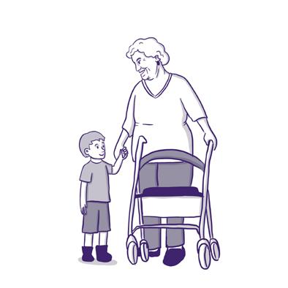

24

Evidence and lessons help forge the shared pathway. To enable generational shifts our way forward needs to be constantly adjusted to reflect what we have learned, and any new insights that emerge. As evidence emerges, and knowledge evolves – our understanding and ability to react must be shared in a collective way so everyone involved can benefit from these insights.

- The Social Wellbeing Agency (SWA) specifically noted the need to, “share knowledge, improve practice, make decisions, and ensure we are moving in the right direction, and the need to continue to develop”.

- The Minister for Courts, Hon Aupito William Sio noted that learning and monitoring needs to be culturally appropriate – if change is to be evidence informed – there should also be consideration as to, “... what is evidence, according to whom?”

- The Safeguarding Adults from Abuse (SAFA) presentation (Sue Hobbs) addressed the need to, “understand that we are embarking on a journey to bring different experiences, where people can be much less isolated to move forward together”.
- A panel of community leaders addressed the importance of government working with communities sustainably for a better way forward.

“Communities exist for themselves. See communities as equals not just bringing them in to contribute as needed.”

Shared responsibility and a shared pathway forward is embedded through relationships and is built on trust and kotahitanga. A range of presenters reinforced this.

- South Auckland Social Wellbeing Board (Ann Wilkie) said, “Importance of trust. Trust across government agencies, government to NGO, NGO to NGO. Trust takes time. Trust leads to shared kaupapa.”

- Debbie Power (CE, MSD) noted that, “... trust means you can take more risks and get more innovation”.

- NZ Police Deputy Commissioner Chris de Wattignar said, “Collaboration is key. Trust is vital. Trust between agencies and NGOs.”

- Leaders throughout the Hui spoke about the need for government to work with communities and highlighted the power that communities have to lead the change. Leaders also emphasised communities walk beside whānau and this is where the power needs to sit – with whānau and families.

“Collaboration is key. Trust is vital. Trust between [government] agencies and NGOs”.

“... trust means you can take more risks and get more innovation”.

“We have got to stop looking at things separately... stop silos”.

25

The Tangata Whenua Ministerial Advisory Group will provide advice to the Minister to create the shared pathway for tangata whenua leadership of Te Aorerekura. This presents a useful accountability mechanism. During the presentation by the MAG, speakers noted their intent to create space for feedback from tangata whenua, and the MAG is looking at how to best represent and create mechanisms for people

to bring concerns to them, and specifically noted: “We have got to stop looking at things separately... stop silos.”
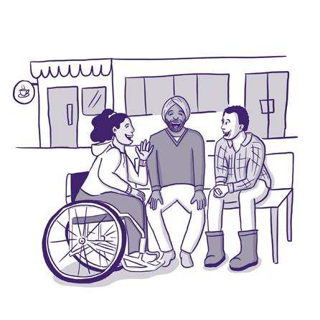

To sum up

Te Aorerekura and its moemoeā set a collective ambition and chart a shared direction towards the elimination of family violence and sexual violence in Aotearoa New Zealand. Each year an Annual Hui provides an opportunity to share our successes, challenges and lessons. It will help ensure mutual accountability across government and for communities

– with all partners able to share what they’re learning and the progress we are making together. The shared pathway needs to be based on trust, kotahitanga, collective learning, sharing and accountability.

26

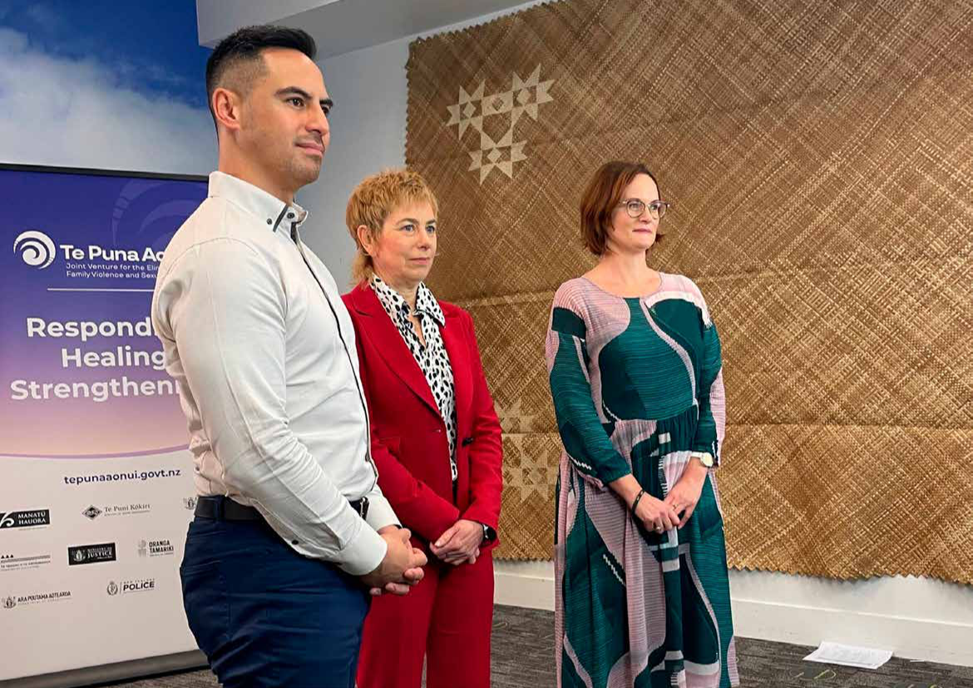

27

There is strong commitment and an appetite for change

Through the two days of the Hui, speakers provided updates and shared their experiences of what is currently happening in communities and in government. It was evident there is commitment across government and in communities to system change and the new ways of working described in Te Aorerekura.

The themes highlighted and analysed in this report provide insight into the current understanding of what’s needed: equity, working with tangata whenua (Te Tiriti), communities, stronger relationships, and the importance of a shared pathway informed by what we learn.

Within these themes, there are priority areas for communities, tangata whenua, government and the specialist sectors, as a whole, to consider and integrate in our collective work to eliminate family violence and sexual violence in Aotearoa New Zealand:

Addressing inequities

The underlying causes of family violence and sexual violence can be exacerbated by the inequities that exist in society. A common thread heard at the Hui was the need to create equity and enable the conditions for wellbeing, to reduce the likelihood of violence.

There must be a focus on addressing socioeconomic inequities as a fundamental issue related to family violence and sexual violence. The interconnected issues, along with intersectionality

and appropriate responses need to be at the forefront of people-centred solution design. The specialist sectors and government must think about intersections – how to best support, tailor, and facilitate better outcomes for those facing multiple issues.

28

Tangata whenua leadership

It’s important for government to further evolve relationships with tangata whenua. There is deep commitment among many in the system to reflect te ao Māori and uphold Te Tiriti o Waitangi in work to eliminate family violence and sexual violence.

While Te Aorerekura puts Te Tiriti at the centre, it’s essential it is translated into how we work so it is seen, heard, honoured and felt across communities, tangata whenua and the specialist sectors. We must go beyond words on a page to bring the intent of Te Aorerekura to life. Ensuring Te Tiri o Waitangi, te ao Māori principles, matauranga and tikanga are embedded in our ways of working means government must consider and acknowledge the dominance of Western structures, processes and world views to actively break down assumptions and make space for different ways of doing things. Each community will require ways of working to be tailored to them so we co-design solutions that meet their specific needs.

Activating the power of communities
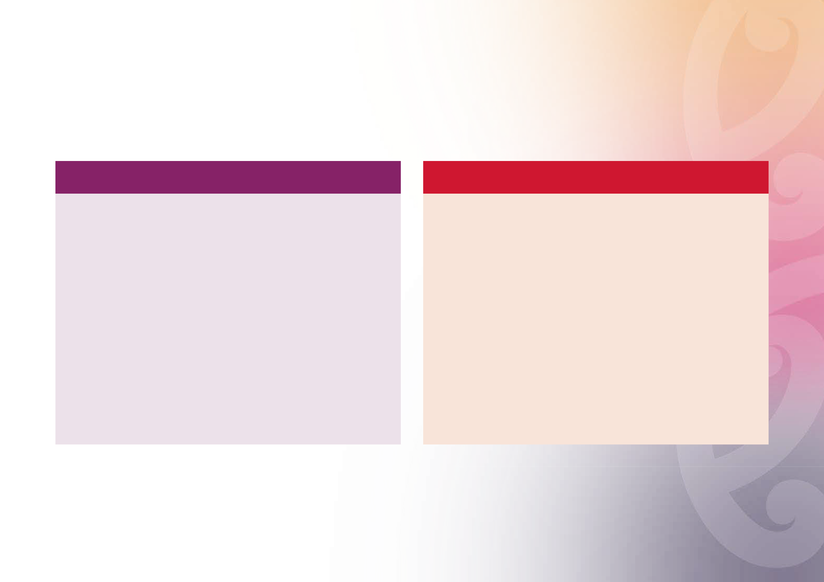

Community-led approaches require communities to be at the decision-making table and able to contribute to designing solutions. There is a need to continue working to devolve resources and enable government to be accountable to communities, just as communities are accountable for delivery of initiatives commissioned by government. There is a need to build trust and relationships to fully realise the potential of all the people involved and to recognise the full potential and impact of community-based solutions and services. Hui participants and presentations highlighted the need for a shift of the power dynamic between community and government in order to strengthen partnerships. The value of communities collaborating with each other to ensure shared understanding was also reinforced.

29

Working together and
strengthening relationships

It’s important for people to come together to achieve the vision of Te Aorerekura, with mana-enhanced, trusting relationships at all levels, focusing on people and values.

Through collaborations, rōpū and networks we can see the benefits of a joined-up response to family violence. This can be led by whānau and communities, with power devolved, regionally enabled and nationally supported. Respectful relationships include honouring the relationships with mana whenua, sharing power, and listening to each other.

Shared pathway forward

The shared pathway needs to be based on trust, kotahitanga, collective learning, sharing and accountability.

The importance of everyone working toward a common goal with a shared pathway that allows for the strengths of different people and parts of the system should be encouraged and informed by what we learn.

Accountability to the collective direction is crucial. Change cannot be realised by single actions in silos – it must be many actions aligned, with all of us working together and moving in the same direction as we work together.

30

How you can support the kaupapa

- If it’s safe to, have a conversation with your whānau, family, friends, and colleagues about what family violence and sexual violence are, what causes violence and abuse, and how you can contribute to healing and prevention. Learn more from the sources below.

- If someone needs help, find out more about understanding violence and abuse, services and supports from: Safe to Talk – Sexual Harm. Do you want to talk? | Safe to talk and Family Violence help – Are You OK
- Read Te Aorerekura- the National Strategy to Eliminate Family Violence and Sexual Violence, watch the Hui videos, and discuss it with your team, community, and organisation.

- Assess your knowledge and share the Specialist Family Violence Organisational Standards and the Entry to Expert Family Violence Capability Framework. Learn more about what organisations and workers need to be able to deliver family violence responses safely and well: Developing family violence capability for workforces and organisations | Te Puna Aonui

- Get involved in your local network, rōpū or collaboration that is working to respond to family violence and/ or sexual violence

- Find out about sexual violence primary prevention, what works and how to evaluate prevention efforts from the Sexual Violence Primary Prevention Toolkit Home » Making a difference: (svpptoolkit.nz)

- Read the Family Violence Death Review Committee reports and use the reflective practice questions within your team and organisation to identify what changes you can make to be more responsive to people impacted by, and people using, family violence Family Violence Death Review Committee | Health Quality & Safety Commission (hqsc.govt.nz)

- Engage with the New Zealand Family Violence Clearinghouse, the national centre for research and information on family, whānau and sexual violence in Aotearoa New Zealand www.nzfvc.org.nz – search their library, read the issues papers, keep up to date with news, training, and events through their newsletter

- Get on the mailing list for panui from Te Puna Aonui by emailing contact@tepunaaonui.govt.nz

31

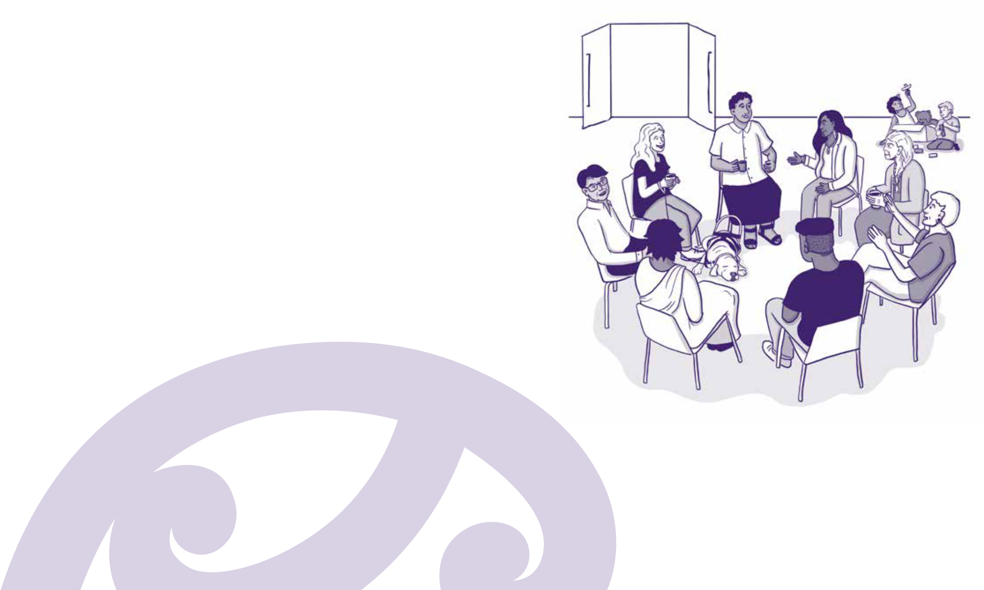

Next steps and Hui 2023

The inaugural Te Aorerekura Hui took place less than a month after standing up Te Puna Aonui, and just seven months after the Strategy and Action Plan were launched. The themes and lessons from the Hui will be fed into work at Te Puna Aonui and will inform the development of the next Action Plan update (due January 2024).

Equity, tangata whenua leadership, activating the power of communities, working together, relationships and ensuring a shared pathway are issues that will inform how we make progress to deliver Te Aorerekura.

Planning and development for the next Hui will commence in late 2022 and feedback received this year will shape our planning for 2023.

32

